**Operating System Lab**

**Fall 2024**

**Lab 03 Task**



**Lab Instructor:**

**Kausar Nasreen Khattak**

**Lab Task**

**Q1.** Make the following directory (03 Marks)

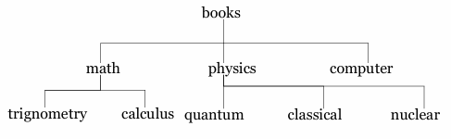

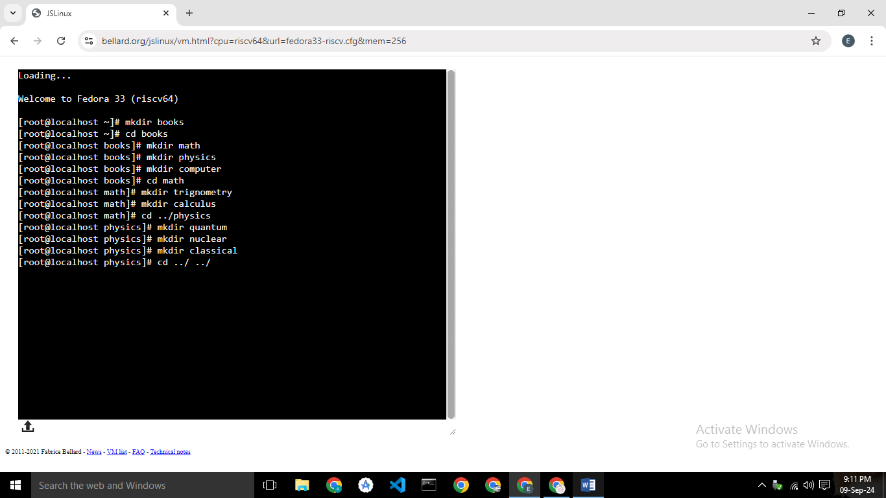

**Q2.** Which are the Linux Directory Commands? Explain the understanding of commands in your own words. Also define what is BASH? (02 Marks)

In Linux, directory commands are used to manage folders

Here are some common directory commands:

1. **Ls :**  Lists files and directories in the current directory.
2. **Cd :** Changes the current directory.
3. **Pwd :**  Shows the present working directory (the directory you are currently in).
4. **Mkdir :**  Creates a new directory.
5. **Rmdir :**  Removes an empty directory.
6. **Cp :** Copies files or directories.
7. **Clear :** To clear the screen

**BASH**  
  
BASH is like a translator that helps you talk to your computer using commands. When you type a command, BASH understands it and tells the computer what to do. It's a tool that makes it easier to control your computer by typing instructions.

**Q3.** 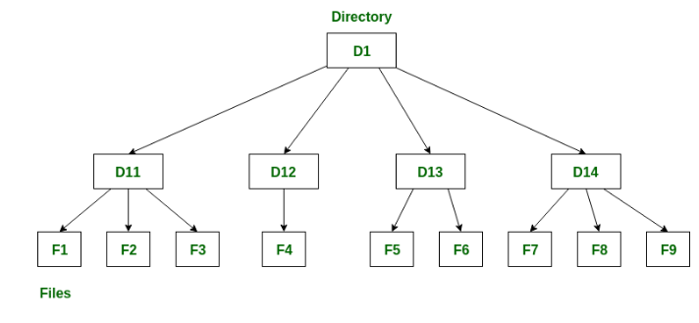

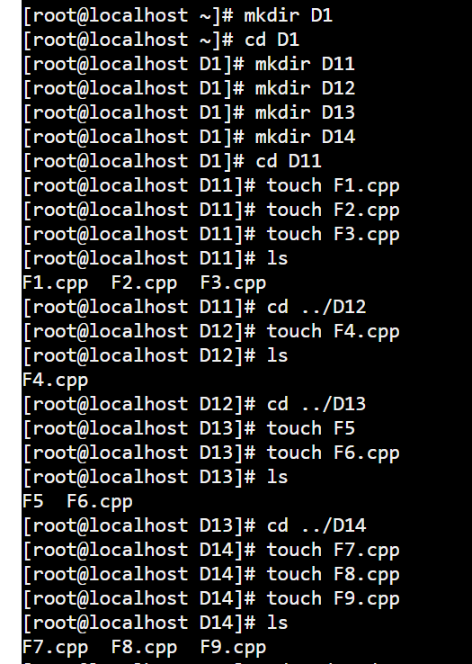

**Q4.** Make the following directory (03 Marks)

